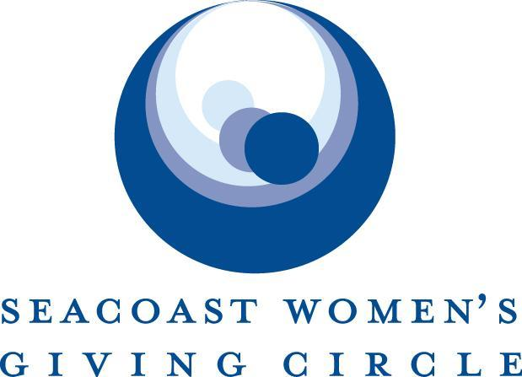

2021 Request for Proposals
Topic: Strengthening Resilient Communities During a Pandemic
$15,000 Grant - Unrestricted Funds

The Seacoast Women’s Giving Circle is accepting proposals from organizations that serve vulnerable populations impacted by the pandemic. Successful proposals should address one or more of the following: childcare, food insecurity, health or homelessness.

Applicants must:
- Be an approved 501(c)(3) tax-exempt organization
- Provide services that support constituents from some or all of the following Seacoast towns of NH and Maine: Seabrook, Hampton, Hampton Falls, North Hampton, Rye, Portsmouth, New Castle, and Kittery

The following organizations are generally NOT eligible for support:
- Religious or faith-based programs or organizations
- Political organizations or programs
- Organizations that discriminate in any way

Seacoast Women’s Giving Circle Priorities:
- Improving quality of life on the Seacoast
- Serving the socio-economically underprivileged
- Fostering independence and self-reliance
- Addressing emerging needs and issues
- Providing long-term solutions
- Investing in the expansion of existing organizations rather than the creation of new ones

TIMELINE

Monday, January 25, 2021: Proposals due

By April 9, 2021: Grant recipients notified

May 12, 2021: Celebration for 2021 grant recipients

Summer 2021: Funds distributed

GRANT AMOUNT

We are accepting applications for $15,000 unrestricted funding grants

2021 GRANT APPLICATION
Please ensure all required documents are included. We accept documents in Word or PDF format. Proposals are considered only when all components of the grant application are submitted.

Please email completed grant application (summary and narrative) and attachments (A, B and C) separately to: give.swgc@gmail.com

___Summary Form

___Narrative

___Attachments A, B, and C

SUMMARY FORM – REQUIRED

- Name of Organization
- Legal name (if different)
- Organization Federal Tax I.D.#
- Organization address
- Phone number
- Website address/Facebook page
- Year founded
- Executive Director’s name
- Contact person for this proposal
(Name, title, phone, email)
- Organization mission/vision statement
- Statement of grant purpose. How will the funds be used to respond to the impact of the pandemic on your organization? (“This grant will be used to…”)
- Please provide a demographic overview of the number of your constituents served in our catchment area -- Seacoast towns of:
Seabrook, Hampton, Hampton Falls, North Hampton, Rye, Portsmouth, New Castle, and Kittery

- Which of the SWGC priorities does this grant address?

- Improving quality of life on the Seacoast
- Serving the socio-economically underprivileged
- Fostering independence and self-reliance
- Addressing emerging needs and issues
- Providing long-term solutions
- Investing in the expansion of existing organizations rather than the creation of new ones
- Number of paid staff (part/full-time)
- Number of volunteers (excluding board members)
- Size of Board of Directors
- How did you learn of this grant opportunity?
NARRATIVE – REQUIRED
The total length of the narrative section should not exceed 3 pages in size 12 font.

- Organization Overview
Provide an overview of your agency, its history, mission, vision, and primary programs and services. Please emphasize major organizational achievements and outcomes that serve your mission. What role does your organization play in serving the greater community?

- Proposal
Provide a detailed description of the need this proposal addresses and how you plan to use the SWGC funds. Please give a general description of how your organization has been impacted by the pandemic and provide examples of how you are using innovative ways to meet your clients’ needs in the context of this challenging environment.

- Measure of Success
How will you evaluate the success of this proposal? Please include qualitative and quantitative measurables.
- Funding Plan and Sustainability
Provide a detailed budget for your proposal. What, if any, funding is required outside of the SWGC grant and how will you secure it?

- Pandemic Relief Funding
Have you applied for and/or received any pandemic relief funding? If so, please explain.

- Resources and Timeline
Discuss the resources available to implement this grant proposal (i.e. staff/board time, skills, commitment). Provide a timeline for use of funds.

- Collaboration
Do you collaborate with other organizations to accomplish your goals? What does each of you bring to the table and how do you avoid duplication of efforts?

Please include anything else you would like us to know.

ATTACHMENTS - REQUIRED
Please clearly label all attachment files with your organization’s name and provide:

- Organization’s most recently filed 990 Form. Please include income statement, balance sheet, current operating budget, and breakdown of organizational revenue sources for past fiscal year (include any Federal, State, Corporate or Individual giving).

- Board of Directors list, including length of service.

- Executive Director biography including length of service with this organization.

