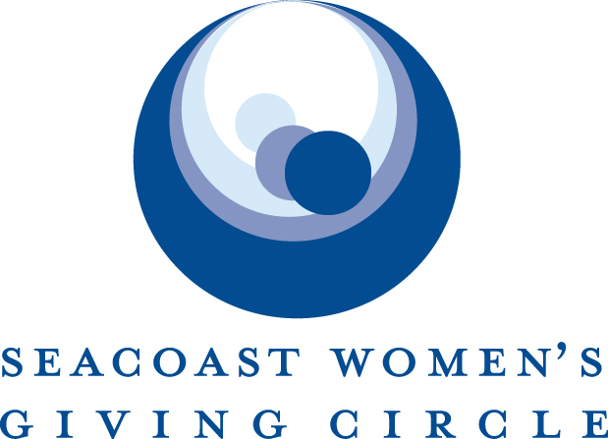

2020 Request for Proposals
Topic: Trauma
$15,000 Grant

The Seacoast Women’s Giving Circle is accepting proposals that aim to reduce the impact of Trauma due to Adverse Childhood Experiences (ACEs).

Applicants must:
- Be an approved 501(c)(3) tax-exempt organization
- Provide services that support constituents from some or all of the following Seacoast towns of NH and Maine: Seabrook, Hampton, Hampton Falls, North Hampton, Rye, Portsmouth, New Castle, and Kittery

The following organizations are generally NOT eligible for support:
- Religious or faith-based programs or organizations
- Political organizations or programs
- Organizations that discriminate in any way

Seacoast Women’s Giving Circle Priorities:
- Improving quality of life on the Seacoast
- Serving the socio-economically underprivileged
- Fostering independence and self-reliance
- Addressing emerging needs and issues
- Providing long-term solutions
- Investing in the expansion of existing organizations rather than the creation of new ones

TIMELINE

Monday, January 27, 2020: Proposals due

By April 10, 2020: Grant recipients notified

May 13, 2020: Fundraising celebration for 2020 grant recipients

Summer 2020: Funds distributed

GRANT AMOUNT

We are accepting applications for $15,000 grants
2020 GRANT APPLICATION
Please ensure all required documents are included. We accept documents in Word or PDF format. Proposals are considered only when all components of the grant application are submitted.

Please email completed grant application (summary and narrative) and attachments (A, B and C) separately to: give.swgc@gmail.com

___Summary Form and Narrative
___Attachments A, B, and C

SUMMARY FORM – REQUIRED

- Name of Organization
- Legal name (if different)
- Organization Federal Tax I.D.#
- Organization address
- Phone number
- Website address/Facebook
- Year founded
- Executive Director’s name
- Contact person for this proposal
(Name, title, phone, email)
- Organization mission/vision statement
- Statement of grant purpose and how it specifically impacts the issue of Trauma
(“This grant will be used to…”)
- Constituents served by organization
(Include number of people served and their demographics)
- Geographical area served by Organization
(Specify number of constituents served within SWGC catchment area, listed on page 1)
- Which of the SWGC priorities does this grant address?
Improving quality of life on the Seacoast
Serving the socio-economically underprivileged
Fostering independence and self-reliance
Addressing emerging needs and issues
Providing long-term solutions
Investing in the expansion of existing organizations rather than the creation of new ones
- Annual operating budget ($)
- Number of paid staff (part/full-time)
- Number of volunteers (excluding board members)
- Size of Board of Directors
- How did you learn of this grant opportunity?

NARRATIVE – REQUIRED
The total length of the narrative section should not exceed 3 pages in size 12 font.

- Organization Overview
Provide an overview of your agency, its history, mission, vision, and primary programs and services. Please emphasize major organizational achievements and outcomes that serve your mission. What role does your organization play in serving the greater community?

- Proposal
Provide a detailed description of the need this proposal addresses and how you plan to use the SWGC funds.

- Measure of Success
How will you evaluate the success of this proposal? Please include qualitative and quantitative measurables.

- Funding Plan and Sustainability
Provide a detailed budget for your proposal. What, if any, funding is required outside of the SWGC grant and how will you secure it?

- Resources and Timeline
Discuss the resources available to implement this grant proposal (i.e. staff/board time, skills, commitment). Provide a timeline for use of funds.

- Collaboration
Do you collaborate with other organizations to accomplish your goals? What does each of you bring to the table and how do you avoid duplication of efforts?

- Is there anything else we should know?

ATTACHMENTS - REQUIRED
Please clearly label all attachment files with your organization’s name. Please provide:

- Organization’s most recently filed 990 Form. Please include income statement, balance sheet, current operating budget, and breakdown of organizational revenue sources for past fiscal year (include any Federal, State, Corporate or Individual giving).

- Board of Directors list, including length of service.

- Executive Director biography including length of service with this organization.

